District Summary:

* There are 15 schools in the district
* The total number of students in all schools is 39,170
* The total budget for the district is $24,649,428
* The average math score in the district schools is 79.985
* The average reading score in the district schools is 81.878
* 74.981% of students in the district passed math by obtaining a score of 70 or higher
* 85.805% of students in the district passed reading by obtaining a score of 70 or higher
* 65.172% of students in the district passed both math and reading by obtaining a score of 70 or higher in both the subjects

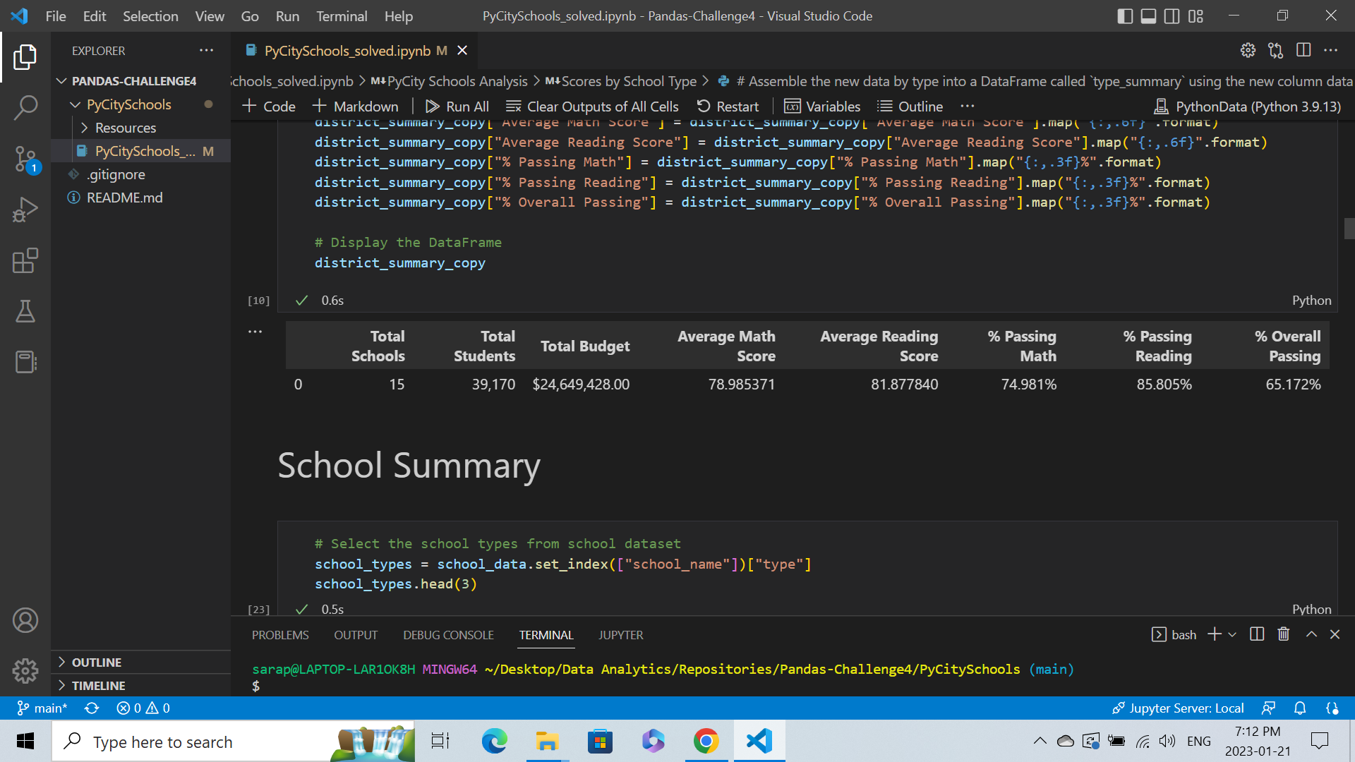

School Summary:

* Charter schools have lesser number of students ranging between 427 to 2283 students for eight schools in the district.
* District schools have greater number of students ranging between 2739 to 4976 students for seven schools in the district.
* The total budget for Charter schools is lower ranging between $0.25 to $1.32 million.
* The total budget for District schools is higher ranging between $1.76 to $3.12 million.
* The budget per student for Charter schools ranges between $578 to $638 per student.
* The budget per student for District schools ranges between $628 to $655 per student.
* The total budget for schools is usually higher for the schools with more students (which is true for most District schools). However, the budget per student does not follow the same trend for all schools. There are some Charter schools with lesser students but have a higher budget resulting in higher per student budget.
* The students enrolled in Charter schools have higher math scores on average (83) compared to the students enrolled in District schools (76-77). The percentage of students passing maths by getting a score of 70 or higher is also higher in Charter schools (92%-94%) as compared to District schools (65%-68%).
* The students enrolled in Charter schools have higher math scores on average (83-84) compared to the students enrolled in District schools (80-81). The percentage of students passing reading by getting a score of 70 or higher is also higher in Charter schools (95%-97%) as compared to District schools (79%-82%).
* The overall passing rate (students passing both maths and reading) is also higher (89%-91%) in Charter schools relative to District schools (52%-54%).

